Q1 | How to specify DTD version of HTML5
 | a) <!DOCTYPE html> b) <!HTML5> c) <DOCTYPE html> d) None of the above

Q2 | Header section in Html5
 | a) h1 b) head c) header d) section

Q3 | How to provide comments in html page
 | a) //single line comment b) /* multi line comments */ c) Both a & b d) <! -- comment -- >

Q4 | Which of the following input control represents a date and time (including all parts like year, month, day, hour, minute, second, fractions of a second) encoded according to ISO 8601 with the time zone set to UTC in Web Form 2.0?
 | a) date b) datetime c) datetime-local d) time

Q5 | How to provide roman in list items at ol tag? a
 | a) <ol type="i"></ol> b) <ol type="r"> </ol> c) <ol type="roman"> </ol> d) All of the above

Q6 | How to group radio buttons into one category?
a) By providing common id b) By providing common name
c) By providing groupname d) all of the above

Q7 | How to provide ListBox in HTML
a) <select> </select> b) <select multiple> </select>
c) <listbox> </listbox> d) None of the above

Q8 | How to provide multiline textbox in html
a) <multiline> </multiline> b) <input type=text multiple>
c) <textarea> </textarea> d) All of the above

Q9 | How to import javascript file in html page?
a) <script src="filename.js"> </script> b) <link rel="script" href="filename.js" >
c) /// <reference path="filename.js" /> d) all of the above

Q10 | How to import css file in html page?
a) <script src="filename.js"> </script> b) <link rel="stylesheet" href="filename.css" >
c) /// <reference path="filename.js" /> d) all of the above

Q11 | The following property in input elemnt provides a hint to the user of what can be entered in the field in HTML5?
 | a) autofocus b) alert c) output d) required

Q12 | How to restrict empty input value before form submission?
 | a) mandate b) autocomplete c) required d) none of the above

Q13 | The following attribute triggers event when the window gets focus
 | a) focus b) onfocus c) onforminput d) All of the above

Q14 | The following attribute triggers events when the document has change?
 | a) onhaschange b) oninput c) onchange d) onloadeddata

Q15 | What is the true about session storage?
a) Gets erased only when the browser is closed, remain when the tab is closed
b) Gets erased when the tab is closed.
c) Will remain even browser is restarted d) None of the above

Q16 | Which of the following are correct about Geolocation API?
A - The geolocation APIs work with a new property of the global navigator object.
B - The geolocation object is a service object that allows widgets to retrieve information about the geographic location of the device.
C - getCurrentPosition() method retrieves the current geographic location of the user.
D - All of the above.

Q17 | HTML5 provide following features under Multi media
a) <video> and <audio> elements b) <multimedia> element
c) Both of the above d) None of the above

Q18 | What is the use of Canvas?
a) Used to draw graphics with html element with properties
b) Used to draw graphics using Javascript with properties
c) Both a & b d) None of the above

Q19 | How to implement threads in HTML5
 | a) Using Thread b) Using WebWorkers c) Using Ajax d) None of the above

Q20 | What is the true above SVG?
a) Used to draw graphics with html element with properties
b) Used to draw graphics using Javascript with properties
c) Both a & b d) None of the above
Task:
1) Create Login Page
restrict page submission when uname and pwd is empty
redirect to success page if input is not empty
2) design the following UI
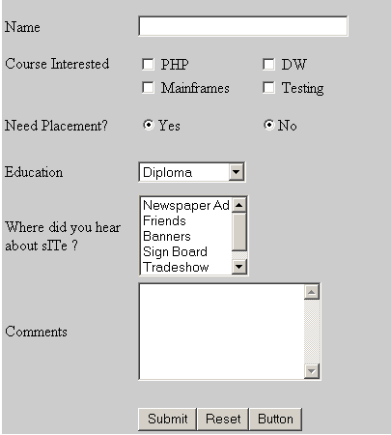
3) Display current location map using geolocation feature
4) Assign your name and city in one browser page and open in another tag
5) Design the following table
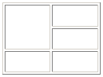

Sl.No | Correct Option | Sl.No | Correct Option
1 | a | 11 | d
2 | b | 12 | c
3 | d | 13 | b
4 | c | 14 | c
5 | a | 15 | a
6 | b | 16 | d
7 | a | 17 | a
8 | c | 18 | b
9 | a | 19 | d
10 | b | 20 | d

